|  |  |  |  |  |  |  |  |  |  |  |  |  |
| --- | --- | --- | --- | --- | --- | --- | --- | --- | --- | --- | --- | --- |
| **FYP MID Defense Template**  ***Sukkur IBA University***  **Software Requirements Specification (SRS)**  For  [IoT Based Real Time Patient Health Monitoring System]  Version [1.0]  [Team Members: Mashooque Ali & Saad Ishaq]  [Supervisor: Dr. Syed Asif Raza Shah]  Date of preparation 21-04-2021   |  |  | | --- | --- | | *Project Code* | *F17144* | | *Supervisor* | *Dr. Syed Asif Raza Shah* | | *Co-Supervisor* | *Mr. Nisar Ahmed Siddiqui* | | *Project Manager* | *Mashooque Ali* | | *Project Team* | *Mashooque Ali*  *Saad Ishaq* | | *Submission Date* | *21-04-2021* | |

**Document History**

|  |  |  |  |
| --- | --- | --- | --- |
| **Version** | **Name of Person** | **Date** | **Description of change** |
| *1.0* | *Dr. Syed Asif Raza Shah* | *21-04-2021* | *Document Created* |
|  |  |  |  |

**Distribution List**

|  |  |  |
| --- | --- | --- |
| **Name** | **Role** | |
| *Mr. Nisar Ahmed Siddiqui* | | *Co-Supervisor* |
| *Mashooque Ali* | | *Project Manager* |
|  | |  |

**Document Sign-Off**

|  |  |  |  |
| --- | --- | --- | --- |
| **Version** | **Sign-off Authority** | **Project Role** | **Sign-off Date** |
| *1.0* | *Dr. Syed Asif Raza Shah* | *Supervisor* | *21-04-2021* |
|  |  |  |  |
|  |  |  |  |
|  |  |  |  |
|  |  |  |  |
|  |  |  |  |
|  |  |  |  |

**Table of Contents**

1 Introduction 6

1.1 Purpose of the document. 6

1.2 Intended audience. 7

1.2.1 Primary User: 7

1.2.2 Secondary Users: 7

1.3 Document Convention 7

1.4 Project Scope 7

1.5 Not in Scope. 8

2 Overall System Description 8

2.1 Project Background 8

2.2 Project Objective. 8

2.3 Stakeholders. 9

2.3.1 Direct stakeholders: 9

2.3.2 Indirect stakeholders: 9

2.4 Operating Environments. 9

2.5 System Constraints. 9

2.6 Assumptions and Dependencies 10

3 External Interface Requirements. 10

3.1 Hardware Interfaces 10

3.2 Software Interfaces. 10

3.3 Communication Interfaces. 11

4 Functional Requirements 11

4.1 Functional Hierarchy 11

4.2 use cases 12

4.2.1 IoT Based Real Time Patient Health Monitoring System 12

5 Non-Functional Requirements. 17

5.1 Performance Requirements. 17

5.1.1 AD8232 ECG Sensor and pulse sensor 17

5.1.2 Mg811 co2 sensor 18

5.1.3 Digital Infrared Temperature Sensor MLX90614 18

5.2 Safety Requirements. 19

5.3 Security Requirements. 19

5.4 User Documentation 19

6 References 20

# Introduction

Health is the priceless thing in the human life, and everyone try their best to keep themselves healthy. On other side, diseases are the real enemy of human health and nowadays, persons’ health is compromised because of the communicable diseases. Moreover, doctors and medical staff are at high risk because they need to interact with patients physically. In communicable diseases, if victims are 100 then 30 out of 100 are those victims who got interacted with the patient physically[1]. By considering the above scenario we are proposing the IoT Based Real Time Patient Health Monitoring System as solution to this problem. In this system we are monitoring the four vital signs of human body, 1) Body Temperature 2) Pulse Rate 3) Respiration Rate 4) Blood Pressure. We will use IoT sensors to measure these vital signs of human body and with the help of Arduino and WIFI modules data will be uploaded on web server in real time, and it will be accessed through mobile and web application. Furthermore, our system will prescribe medicine or treatment if patient’s condition is abnormal. This system has two types of users, Primary (doctors and related staff) and secondary (patient relatives) to monitor the patient health with different privileges. In conclusion, this health monitoring system will minimize the risk of spreading the communicable diseases and inform the users about the health of patient.

## Purpose of the document.

The main purpose of this document is to provide complete information (functional and non-functional requirements) about our system which will help the new emerging researchers to extend our project or add new functionalities like involving of Artificial Intelligence (AI).

## Intended audience.

### Primary User:

* Doctors and other Medical staff:

All hospitals and medical related market who want Real time patient monitoring will take benefit from this.

### Secondary Users:

* Patient Relatives:

As we know patient relatives always conscious about the patient health and they want real time update about the patient’s health.

## Document Convention

* Font: Time New Roman
* Font Size:
  + Normal text 12
  + Heading’s text 16
  + Subheading’s text 14

## Project Scope

* Our system is monitoring the four vital signs in single and upload the data to webserver at runtime, no one has done work on these four vital signs in single module[1].
* Our system application will maintain the patient history.
* Our system will generate alert (Message on Sim card and application) if patient condition become abnormal.
* Our system application will be accessible everywhere in the world.
* We will develop a cross-platform mobile application and we application for our system.
* Our system will be available in affordable price.

## Not in Scope.

* Our system application will not recommend the medicine or treatment and will not give intelligent prescription be using any AI Model.

# Overall System Description

## Project Background

Many people lose their lives and health every day because of communicable diseases, but how can we reduce the spread of these diseases? As communicable diseases spread because of the frequent physical contact with the patient and their death occur because of poor monitoring of the patient[1]. Mostly in hospital, availability of doctors and other medical staff is a major issue and because of this monitoring of the patient is almost impossible. Moreover, if a person from medical staff is monitoring the patient manually then there are chances of human-error and human life is not that much cheap to be compromised. Person from medical staff is also at high risk who is continuingly monitoring the patient.

## Project Objective.

Nowadays, Technology is too much advanced to solve the real-life problems. In medical side computer science technology has many contributions but still there are some gaps like poor monitoring systems in medical area[2]. Our project main goal is to monitor the four vital signs (Temperature, Blood pressure, Pulse Rate, Respiration Rate) of the patient at real time 24/7 using IoT sensors. Moreover, if any unwanted situations occur (like, variations in respiration and pulse rate, increasing temperature and blood pressure) then our system will generate alert to the patient’s doctor and will prescribe medicine or treatment to the available medical staff.

* Our system is monitoring the four vital signs in single and upload the data to webserver at runtime, no one has done work on these four vital signs in single module[2].
* Our system will generate alert (Message on Sim card and application) if patient condition become abnormal.
* Our system will be available in affordable price.

After the completion of the project, our system will be able to sense the data from human body, upload the data to webserver at runtime and data will be accessed through mobile and web application everywhere in the world. Furthermore, we will upload on play store and will host the web application for the accessibility. Hardware also will be deployed in compatible size.

## Stakeholders.

There are two types of the stakeholders, one who get direct benefit from the system is call direct stakeholder and one who get indirect benefit is called indirect stakeholder.

### Direct stakeholders:

Developers of the system (Mashooque Ali & Saad Ishaq) and Sukkur IBA University.

### Indirect stakeholders:

Medical institutes, hospitals, paramedical staff, and patient relatives.

## Operating Environments.

Our system will be operatable at hospitals, homes or at any place wherever the patient is, but internet connectivity and electricity should be available. Moreover, for connecting the system module to internet there should be a router or access point (AP) so the system can upload the sensed data to webserver. User must have a smart phone/laptop or PC to access the application for getting the real time data.

## System Constraints.

Software constrains: Application will be compatible with android and iOS operating system.

Hardware constraints: Internet, Electricity and Smart Phone/PC must be available.

Cultural constraints: user must understand the English language.

Environmental constraints: system must keep away from water or any other liquid because sensors could give wrong reading if they got wet.

User constraints: system is not developed for kids moreover; it is not for entertainment.

## Assumptions and Dependencies

We are assuming that you have placed sensors on the patient in right way and the data from sensors is accurate because our system application and doctor will take decision according to that data.

# External Interface Requirements.

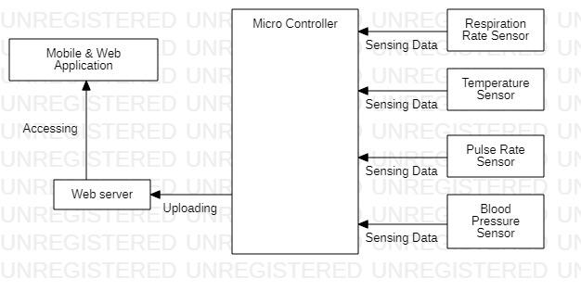

## Hardware Interfaces

These four sensors (Respiration rate, Temperature, Pulse rate, Blood pressure) will be connected to microcontroller and data will be upload on server, after that this data will be accessed through mobile or web application. These sensors will give data in analog and digital form and at mobile application side this data will be in text form.

## Software Interfaces.

Our system module will be embedded with webserver called ThingSpeak, it is an IoT platform where sensors data will be sent and retrieved. We upload the data of patient like Temperature, Respiration rate, Pulse rate, Blood pressure on web server to make it accessible for doctor so he can provide treatment for it and for relatives so they can see the condition of their dears.

## Communication Interfaces.

Our system will use a virtual mobile number to send the alert the doctors on mobile phone if internet connectivity if not available. Moreover, we will use MQTT and HTTP to transfer/retrieve the data to/from ThingSpeak.

# Functional Requirements

## Functional Hierarchy

Patient

User will be authorized according to their role, with different privileges.

Patient relatives on can see the patient profile and condition

Only see

Doctor can prescribe something after observing the patient condition

Medical Staff

Sensors

Prescription

Doctor

Relatives

Login

IoT Based Real Time PHMS

Web Server

## use cases

### IoT Based Real Time Patient Health Monitoring System

This is login use case where users will login through username and password.

|  |  |  |  |  |
| --- | --- | --- | --- | --- |
| ***<Use case Id: login 1.1>*** | | | | |
| ***Use case Id:*** | | login 1.1 | | |
| ***Actors:*** Doctor, Medical Staff, Patient Relatives. | | | | |
| ***Feature:*** authentication and authorization | | | | |
| ***Pre-condition:*** | | Use must create account to execute this use case | | |
| ***Scenarios*** | | | | |
| ***Step#*** | ***Action*** | | | ***Software Reaction*** |
| ***1.*** | User will enter ID and password | | | Authentication will be performed, and user will be authorized if account exists |
| ***Alternate Scenarios:*** | | | | |
| ***1a:*** *if user forgot his/her password he/she can reset the password and create new password.* | | | | |
| ***Post Conditions*** | | | | |
| ***Step#*** | ***Description*** | | | |
| ***1*** | User will be authorized | | | |
| ***2*** | user will be able to perform all permitted operations like view records, update if permitted | | | |
|  |  | | | |
| ***Use Case Cross referenced*** | | | This use case does not use any other use case. | |

This is adding patient use case where, high privilege user will create profile of patient or will make some changes.

|  |  |  |  |  |
| --- | --- | --- | --- | --- |
| ***<Use case Id: add Patient 1.2>*** | | | | |
| ***Use case Id:*** | | Add Patient 1.2 | | |
| ***Actors:*** Doctor | | | | |
| ***Feature:***patient registration | | | | |
| ***Pre-condition:*** | | User must login through doctor’s account | | |
| ***Scenarios*** | | | | |
| ***Step#*** | ***Action*** | | | ***Software Reaction*** |
| ***1.*** | Doctor will create patient profile. | | | Information will be stored in database |
| ***2.*** | Doctor will add patient information and  Patient history. | | | Information will be stored system will start showing the data receiving from the assigned patient ID. |
| ***Post Conditions*** | | | | |
| ***Step#*** | ***Description*** | | | |
| ***1*** | Patient profile will be created | | | |
| ***2*** | Patient data will be shown on application | | | |
| ***3*** | Patient relatives can see the condition, and doctor also can prescribe something to the patient. | | | |
| ***Use Case Cross referenced*** | | | <create patient profile 1.2.1> <add patient info 1.2.1.1> <add patient history1.2.1.2> | |

This is view records use case, many actors will launch it to view the record of patient.

|  |  |  |  |  |
| --- | --- | --- | --- | --- |
| ***<Use case Id: view records 1.3>*** | | | | |
| ***Use case Id:*** | | View Records 1.3 | | |
| ***Actors:*** Doctor, medical staff, patient relative. | | | | |
| ***Feature:*** Real time patient condition will be shown | | | | |
| ***Pre-condition:*** | | User must have an account to login | | |
| ***Scenarios*** | | | | |
| ***Step#*** | ***Action*** | | | ***Software Reaction*** |
| ***1.*** | User can request to see the patient record, like temperature, pulse rate, blood pressure and respiration rate. | | | System will show the data in graphical form and as well as in text form. |
| ***Alternate Scenarios:*** Write additional, optional, branching, or iterative steps. Refer to specific action number to ensure understandability. | | | | |
| ***1a:*** if privileges are given, user can update the records | | | | |
| ***Post Conditions*** | | | | |
| ***Step#*** | ***Description*** | | | |
| ***1*** | Requested data will be visualized to the user. | | | |
| ***2*** | by using the privileges user will perform the operations | | | |
|  |  | | | |
| ***Use Case Cross referenced*** | | | None. | |

This use case will be visible to more than one user, in which they can see the previous history of the patient like, which type of diseases this patient had.

|  |  |  |  |  |
| --- | --- | --- | --- | --- |
| ***<Use case Id: view patient history 1.4>*** | | | | |
| ***Use case Id:*** | | View patient history 1.4 | | |
| ***Actors:***  Doctor | | | | |
| ***Feature:*** user will be able to prescribe and update the history | | | | |
| ***Pre-condition:*** | | User must login through doctor’s account | | |
| ***Scenarios*** | | | | |
| ***Step#*** | ***Action*** | | | ***Software Reaction*** |
| ***1.*** | Doctor will prescribe medicine to the patient | | | Prescription will be stored into the database and will be shown to the medical staff and patient relatives |
| ***2.*** | Doctor will be updated history after prescription and identifying the new diseases. | | | System will update the information and store it into the database. |
|  |  | | |  |
| ***Alternate Scenarios:*** | | | | |
| ***1a:*** Doctor can prescribe some treatment instead of medicine, or nothing if condition is acceptable. | | | | |
| ***Post Conditions*** | | | | |
| ***Step#*** | ***Description*** | | | |
| ***1*** | User will be able to view patient history | | | |
| ***2*** | user will be able to prescribe something to patient | | | |
| ***3*** | User will be able to update the patient history | | | |
| ***Use Case Cross referenced*** | | | <prescribe 1.4.1> <update 1.4.2 > | |

This use case will be initiated by the sensors, in which sensors will sense the data and through microcontroller it will upload that data on webserver.

|  |  |  |  |  |
| --- | --- | --- | --- | --- |
| ***<Use case Id: sense the data 1.5>*** | | | | |
| ***Use case Id:*** | | Sense the data 1.5 | | |
| ***Actors:*** Sensors | | | | |
| ***Feature:***readings related to the patient health will sensed. | | | | |
| ***Pre-condition:*** | | Sensors must be placed on the patient body in right way. | | |
| ***Scenarios*** | | | | |
| ***Step#*** | ***Action*** | | | ***Software Reaction*** |
| ***1.*** | Data will be sensed through sensors from the patient body. | | | Software will show that data on the GUI |
| ***Post Conditions*** | | | | |
| ***Step#*** | ***Description*** | | | |
| ***1*** | Data will be received | | | |
| ***2*** | System and privileges user will be able perform operations and take decision | | | |
|  |  | | | |
| ***Use Case Cross referenced*** | | | None. | |

This use case also will be initiated by sensor, will send that to webserver through microcontroller.

|  |  |  |  |  |
| --- | --- | --- | --- | --- |
| ***<Use case Id: send data 1.6>*** | | | | |
| ***Use case Id:*** | | Send data 1.6 | | |
| ***Actors:***  *Sensors* | | | | |
| ***Feature:*** data will be available at system side to perform some operations | | | | |
| ***Pre-condition:*** | | Microcontroller must be connected to internet connection | | |
| ***Scenarios*** | | | | |
| ***Step#*** | ***Action*** | | | ***Software Reaction*** |
| ***1.*** | Data will be sent in analog and digital form | | | software will receive that data and store it into database |
| ***2.*** |  | | |  |
|  |  | | |  |
| ***Alternate Scenarios***. | | | | |
| ***1a:*** software will store the data into database in text form. | | | | |
| ***Post Conditions*** | | | | |
| ***Step#*** | ***Description*** | | | |
| ***1*** | Data will be available to perform some operation | | | |
|  |  | | | |
|  |  | | | |
| ***Use Case Cross referenced*** | | | None | |

This use will be initiated by the system to alert the doctor with a message which contain the patient condition information.

|  |  |  |  |  |
| --- | --- | --- | --- | --- |
| ***<Use case Id: send alert to doctor 1.7>*** | | | | |
| ***Use case Id:*** | | Send alert to doctor 1.7 | | |
| ***Actors:*** This use case will be initiated by the system | | | | |
| ***Feature:*** doctor will be notified when patient condition become abnormal | | | | |
| ***Pre-condition:*** | | Internet connectivity must be available. | | |
| ***Scenarios*** | | | | |
| ***Step#*** | ***Action*** | | | ***Software Reaction*** |
| ***1.*** | System will observe the patient condition and send alert according to the condition | | | Software will allow the system to send to alert using its services. |
| ***Post Conditions*** | | | | |
| ***Step#*** | ***Description*** | | | |
| ***1*** | Doctor will be notified | | | |
| **2** | Doctor will be to see the critical patient. | | | |
|  |  | | | |
| ***Use Case Cross referenced*** | | | <observe the patient condition 1.7.1 > | |

# Non-Functional Requirements.

## Performance Requirements.

As we know health related data is very sensitive, a single error can cause wrong treatment suggestion and it will lead to cause the death of the patient. Moreover, accessing the server from application will have zero latency, and sensors will transfer data according to their accuracy. Our system will show the data accessed from sensor within 5-15 seconds, but access time still depends on the speed of the internet connection.

### AD8232 ECG Sensor and pulse sensor

* 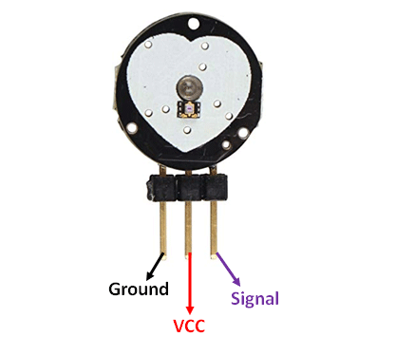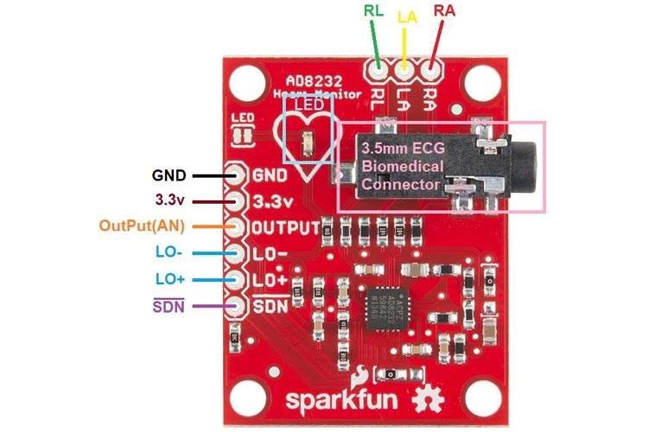Accuracy: +- 0.5 beats per minute

It is a heart rate and pulse rate sensor, which calculates the pulse rate and as well as heart rate. They provide data in analog form, and we can generate ECG report using these sensors.

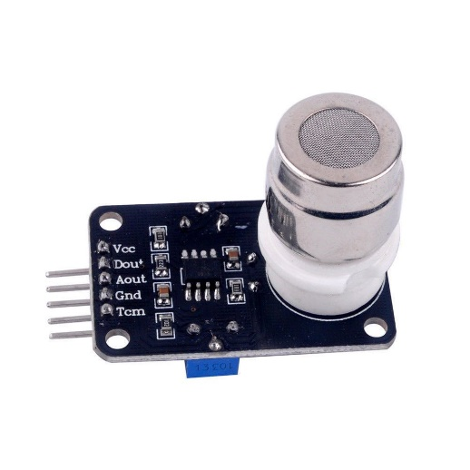

### Mg811 co2 sensor

* Accuracy: +-0.2 breaths per minute
* Small size and low cost

This sensor is used to measure the Corban Dioxide in the respiration. It provides data in digital form and as well as in analog form. We will use this sensor to calculate the respiration rate.

### Digital Infrared Temperature Sensor MLX90614

* 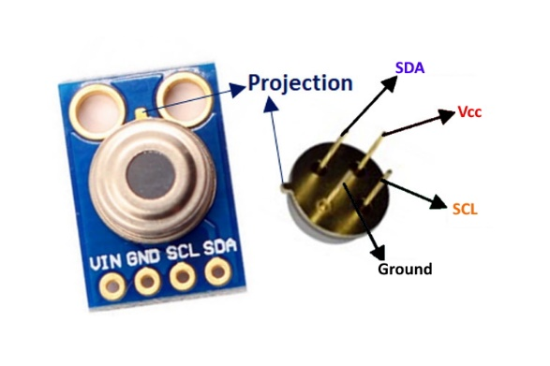Temperature Range: -40 to +125C for sensor temperature and -70 to + 380C for object temperature.
* Accuracy: 0.5C
* low cost and small size

It is an infrared temperature sensor which calculate the temperature of the object using IR signals when object is placed with the distance of 3-5cm in front of this sensor.

## Safety Requirements.

Not applicable.

## Security Requirements.

Not applicable.

## User Documentation

We will provide the step-by-step description in our manual and online tutorial that

1. How the sensors will be connected and places on patient.
2. How to create an account and in which category you should create.
3. How to create the profile of patient and enter history of the patient (only for medical staff).
4. How to check the patient history

# References

1. Bin, S., G. Sun, and C.-C. Chen, *Spread of infectious disease modeling and analysis of different factors on spread of infectious disease based on cellular automata.* International journal of environmental research and public health, 2019. **16**(23): p. 4683.

2. Yelane, P., A. Wagh, and T.A.N. Shaha Sh, *A Review on Patient Monitoring System using IoT.* International Journal on Recent and Innovation Trends in Computing and Communication, 2018. **6**(3): p. 152-154.